Impact and Evaluation Senior Manager

APPLICANT INFORMATION PACK
The work of our foodbank network is inspiring, but we face significant challenges ahead. Between 1st April 2019 and 31st March 2020, food banks in the Trussell Trust network distributed 1.9 million three-day emergency food supplies to people in crisis, a 18% increase on the previous year. More than 700,000 of these went to children.

I want to see the end of the need for emergency food services in every nation of the UK, to work with governments at every level to ensure that our benefits system provides a genuine safety net for people and work is paid a fair wage, allowing individuals and families to thrive rather than just stave off crisis.

Working for the Trussell Trust means making a difference in people’s lives. To continue our vital work, we rely on a team of dedicated people. Come and join one of the fastest growing charities in the UK!

Emma Revie
Chief Executive
Welcome from
Emma Revie, Chief Executive
Our values
What we Do
*14.2 million people in the UK population are in poverty.
The Social Metrics Commission, 2018
Our aim is to end hunger and poverty in the UK. We support a nationwide network of 1,200 food bank centres across the UK.

Together, we provide emergency food and support to people locked in poverty, and campaign for change to end the need for food banks in the UK for good.

In the UK, more than 14 million* people are living in poverty - including 4.5 million children. As a nation, we expect no one should be left hungry or destitute, and we owe it to each other to make sure the right support is in place when we need it most.

It’s simply not right that we live in a society where so many people are locked in poverty.

Together, we can end hunger and poverty in the UK.

The Trussell Trust is committed to community built on diversity, tolerance, cooperation, and mutual respect. We want to contribute to society and demonstrate social responsibility.

Our values are Compassion, Justice, Community and Dignity.

These are reflective of the values
we see embodied throughout the Trussell Trust network of food banks.

Whilst we recognise that charities, churches and organisations running food banks may hold additional or distinctive values, these are the values which we hold together as a network, and by which we hold one another accountable.
3
Our offices are in Salisbury and London.

We also have team members based across the UK supporting food banks at a local level.

Our support for the food banks in our network is delivered through six directorates, all of which report into our Chief Executive. These are:
• Operations
• Finance & Corporate Services
• Policy, Research and Impact
• Strategy
• Public Engagement

Whatever your skills or experience, there could be a role for you at the Trussell Trust.

Our Benefits
How we Work
Our people are the most important thing the Trussell Trust has. Without our staff, we couldn’t achieve our goals and create change.

Our staff are passionate about their work and the difference they make to the lives of others. The benefits package we offer supports our staff professionally and personally.

Benefits include matched pension contributions of up to 8%, group income protection, payroll giving, flexible working, season ticket loans, and enhanced contractual leave.

To find out more about the full range of benefits we offer, visit www.trusselltrust.org/employee-benefits.

The Role

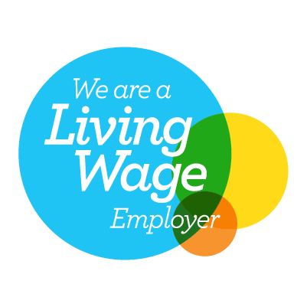

Department: Policy, Research and Impact
Responsible to: Head of Impact and Evidence
Responsible for: Learning and Evaluation Manager (2 further reports), Financial Inclusion Data and Insight Manager
Hours: Full Time (37.5 hours per week)
Salary: £52,637 per annum plus benefits
Based: Home based within the UK with some travel to Salisbury and London Offices or to food banks

ROLE OUTLINE AND PURPOSE
Responsible for ensuring that robust, timely and aligned evidence is readily available from across the breadth of Trussell Trust’s programmes and projects, including those of the Foodbank Network. This role holds responsibility for developing and updating impact frameworks, ensuring that accurate data are collected in line with these frameworks, and overseeing and shaping the way in which we communicate our impact. Working across service delivery, policy influencing and attitudinal change activities, this role is responsible for the delivery of the organisation’s annual Impact Report, and for providing effective oversight and guidance to team members to support impact reporting and evaluation at a programme and project level.

RESPONSIBILITIES
- Support the Head of Impact and Evidence, by leading the operational planning and coordination of our impact measurement work, working collaboratively with colleagues across the organisation to ensure that our approach to evidencing impact is effective, inclusive, consistent and reflects our values.
- Act as owner of our organisational Theory of Change, maintaining the evidence base by bringing together data from across programmes, projects and external sources and highlighting where underpinning assumptions or activity may not be aligned.
- Working closely with colleagues in Strategic Communications and Strategic Intelligence, develop and extend our internal, network and external-facing impact reporting, including managing delivery of our annual Impact Report and ensuring relevant impact data is readily available for support-raising teams.
- Provide expert advice to support effective decision-making about our approach to impact and evaluation, and lead a team of monitoring and evaluation specialists, drawing on their skills in qualitative and quantitative research design and analysis, and ensuring that our Impact and Evaluation team is able to provide a consistent and high-performing service to other teams across the organisation.
- Where necessary, advise on, project manage, and deliver or commission complex evaluations or impact analysis of our programmes as required, working collaboratively with staff accountable for programme delivery.
- Work with team managers and the Head of Impact and Evidence to facilitate regular opportunities for Trussell Trust staff and food bank network colleagues to learn from evaluation and monitoring work, including through workshops and webinars, in ways that promote reflective practice and inform programme development.

Person specification

Technical skills and minimum knowledge:
- Demonstrable experience in and knowledge of a variety of monitoring and evaluation tools and approaches to support impact reporting, including in a voluntary sector or similar context
- Proven research experience and good knowledge of quantitative and qualitative research methods, and what constitutes robust research
- Strong project management skills and experience, including the ability to manage a diverse portfolio of projects effectively
- Demonstrable ability to influence other colleagues to bring about culture change in the area of systems and processes
- Ability to lead a team of specialists and summarise complex information from a range of sources in a strategic and accessible way
- Excellent written and verbal communication skills
Behaviours and competencies:
- Good relational skills including the ability to work effectively as part of a team, with community groups / volunteers, and with people who have lived experience of poverty
- Ability to identify and engage with key project stakeholders
- Able to influence others whilst maintaining valuable relationships
- Ability to prioritise tasks and work to deadlines
- Demonstrate a dedication to the values of the Trussell Trust
- Demonstrates empathy for people from disadvantaged, marginalised or socially- excluded backgrounds
- Role models inclusive behaviours, values and leadership
Key Stakeholders
- Innovation and Programme Development Senior Manager
- Audience Insight Manager
- Strategic Intelligence
- Programme Leads across the organisation
- Trusts and Grants
- Corporate Partnerships

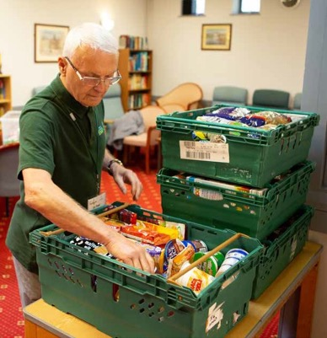
How to apply
The Trussell Trust is a charity that works to end the need for food banks. It is founded on and shaped by Christian principles.
Our values of dignity, justice, compassion and community, are central to all that we do and therefore supports our aim to be an organisation where the diversity of all employees is valued. We welcome people of all faiths and none and those that are committed to these values.
We recognise that we have under-represented groups within our workforce. As part of our commitment to diversity and equality of opportunity we are actively encouraging applications from under-represented groups such as returning parents or carers who are re-entering work after a career break, people who are LGBT+, from Black, Asian and Minority Ethnic backgrounds, with a disability, impairment, learning difference or long-term condition, with caring responsibilities, from different nations and regions and those with a lived experience of poverty as well as any other under-represented group in our workforce. We are committed to ensuring the safety and protection of our employees from all forms of harm.

If you feel you have the required passion, energy and enthusiasm to help us bring an end to poverty and hunger, then you’re on your way to becoming part of something that will make a real difference to people’s lives.

To apply for the role please go to our website to access our online application platform, Applied. This platform enables us to review your application anonymously to make our hiring decisions as diverse and impartial as possible.

You do not have to complete your application in one sitting, but you can save it and go back to it at any time before the closing date.

If you have questions about this position, please call
01722 580 209 or email recruitment@trusselltrust.org.

www.trusselltrust.org/jobs
The Trussell Trust is Reg. Charity in England & Wales (1110522) and Scotland (SC044246). Reg. Ltd. Co. in England & Wales (5434524)

