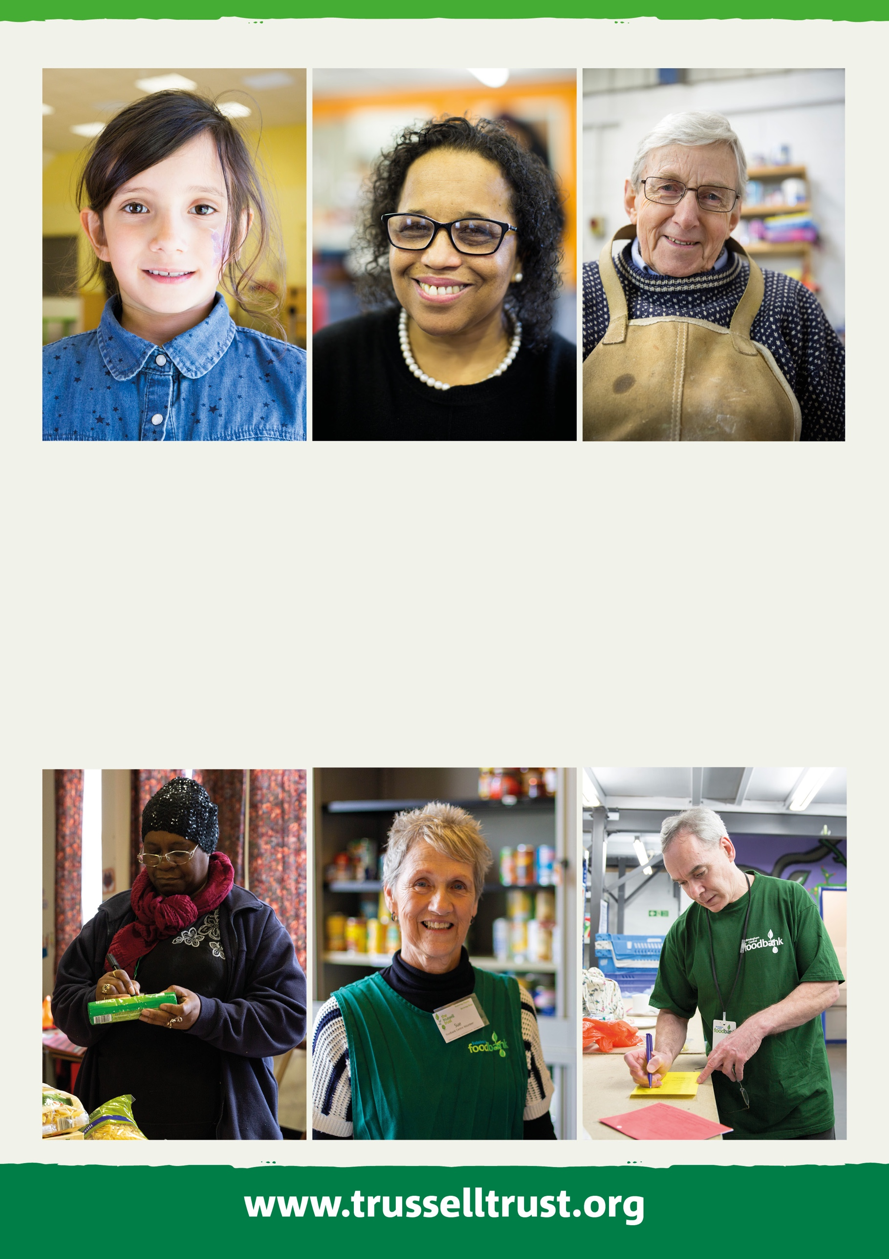
Website Manager

APPLICANT INFORMATION PACK
The work of our foodbank network is inspiring, but we face significant challenges ahead. Between 1st April 2019 and 31st March 2020, food banks in the Trussell Trust network distributed 1.9 million three-day emergency food supplies to people in crisis, a 18% increase on the previous year. More than 700,000 of these went to children.

I want to see the end of the need for emergency food services in every nation of the UK, to work with governments at every level to ensure that our benefits system provides a genuine safety net for people and work is paid a fair wage, allowing individuals and families to thrive rather than just stave off crisis.

Working for the Trussell Trust means making a difference in people’s lives. To continue our vital work, we rely on a team of dedicated people. Come and join one of the fastest growing charities in the UK!

Emma Revie
Chief Executive
Welcome from
Emma Revie, Chief Executive
Our values
What we Do
*14.2 million people in the UK population are in poverty.
The Social Metrics Commission, 2018
Our aim is to end hunger and poverty in the UK. We support a nationwide network of 1,200 food bank centres across the UK.

Together, we provide emergency food and support to people locked in poverty, and campaign for change to end the need for food banks in the UK for good.

In the UK, more than 14 million* people are living in poverty - including 4.5 million children. As a nation, we expect no one should be left hungry or destitute, and we owe it to each other to make sure the right support is in place when we need it most.

It’s simply not right that we live in a society where so many people are locked in poverty.

Together, we can end hunger and poverty in the UK.

The Trussell Trust is committed to community built on diversity, tolerance, cooperation, and mutual respect. We want to contribute to society and demonstrate social responsibility.

Our values are Compassion, Justice, Community and Dignity.

These are reflective of the values
we see embodied throughout the Trussell Trust network of food banks.

Whilst we recognise that charities, churches and organisations running food banks may hold additional or distinctive values, these are the values which we hold together as a network, and by which we hold one another accountable.
3
Our offices are in Salisbury and London.

We also have team members based across the UK supporting food banks at a local level.

Our support for the food banks in our network is delivered through six directorates, all of which report into our Chief Executive. These are:
• Operations
• Finance & Corporate Services
• Policy, Research and Impact
• Strategy
• Public Engagement

Whatever your skills or experience, there could be a role for you at the Trussell Trust.

Our Benefits
How we Work
Our people are the most important thing the Trussell Trust has. Without our staff, we couldn’t achieve our goals and create change.

Our staff are passionate about their work and the difference they make to the lives of others. The benefits package we offer supports our staff professionally and personally.

Benefits include matched pension contributions of up to 8%, group income protection, payroll giving, flexible working, season ticket loans, and enhanced contractual leave.

To find out more about the full range of benefits we offer, visit www.trusselltrust.org/employee-benefits.

Department: Public Engagement
Responsible to: Senior Marketing Manager – Planning & Digital
Hours: Full Time (37.5 hours per week). Flexible working considered
Salary: £36,053 per annum plus benefits
Contract: Fixed term contract until 31st March 2023
Based: Home based with some travel to Salisbury and London Offices

ROLE OUTLINE AND PURPOSE
The website manager will be responsible for day-to-day management and strategic direction of Trussell Trust’s websites. Working within the Brand & Marketing team and with stakeholders across the organisation to ensure our website supports our strategic objectives and helps us achieve our vision of a UK without the need for food banks.

RESPONSIBILITIES
- Overall product management of Trussell Trust and associated food bank websites. This includes managing our website eco-system, maintaining and improving content, managing related agencies and acting as an advocate for best website practice
- Supporting the Senior Marketing Manager – Planning & Digital in the development and delivery of Trussell Trust’s website strategy and wider digital roadmap.
- Responsible for servicing website requests from across the organisation from concept to delivery, providing channel expertise and advice.
- Manage positive internal and external relationships to ensure work is delivered on time, within budget and in line with organisational activity and objectives.
- Ensure user-centric content, journeys and functionality that is delivered to meet organisational goals as well as accessibility standards.
- Proactively analyse and report on website performance, working with other stakeholders to build a clear picture of our websites performance and user experience.
- Ensuring our websites maintains high levels of accessibility as well as compliance

The Role

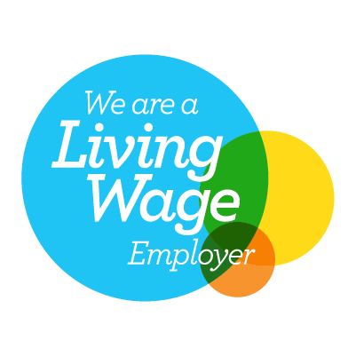

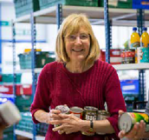

Person specification

Technical skills and minimum knowledge:
- Passion for digital products and delivering outstanding digital user experience
- Experience using Wordpress or similar CMS tools
- Strong understanding of SEO, accessibility and delivering in line with best practice
- Excellent understanding of digital media and the use of digital channels for marketing communications and fundraising
- Strong understanding and knowledge of digital analytics, key metrics and evaluation of online activities
Behaviours and competencies:
- Ability to think strategically and practically deliver
- Demonstrate a commitment to the values of the Trussell Trust
- Demonstrates empathy for people from disadvantaged, marginalised or socially- excluded backgrounds
- Understanding of different access needs covering disability inclusion
- Passionate about the work of the Trussell Trust and able to represent it and its values effectively
- Demonstrates resilience, resourcefulness, flexibility and perseverance
- Excellent ability to co-ordinate and manage a variety of projects simultaneously in a multi-stakeholder environment
Key Stakeholders
- Brand & Marketing team
- Public Engagement directorate
- ICT Teams including CRM teams
- Network Services
- Fundraising and acquisition teams

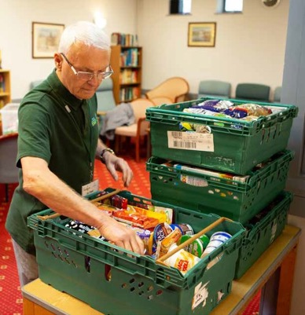
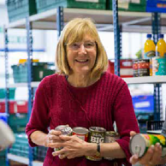
How to apply
The Trussell Trust is a charity that works to end the need for food banks. It is founded on and shaped by Christian principles.
Our values of dignity, justice, compassion and community, are central to all that we do and therefore supports our aim to be an organisation where the diversity of all employees is valued. We welcome people of all faiths and none and those that are committed to these values.
We recognise that we have under-represented groups within our workforce. As part of our commitment to diversity and equality of opportunity we are actively encouraging applications from under-represented groups such as returning parents or carers who are re-entering work after a career break, people who are LGBT+, from Black, Asian and Minority Ethnic backgrounds, with a disability, impairment, learning difference or long-term condition, with caring responsibilities, from different nations and regions and those with a lived experience of poverty as well as any other under-represented group in our workforce. We are committed to ensuring the safety and protection of our employees from all forms of harm.

If you feel you have the required passion, energy and enthusiasm to help us bring an end to poverty and hunger, then you’re on your way to becoming part of something that will make a real difference to people’s lives.

To apply for the role please go to our website to access our online application platform, Applied. This platform enables us to review your application anonymously to make our hiring decisions as diverse and impartial as possible.

You do not have to complete your application in one sitting, but you can save it and go back to it at any time before the closing date.

If you have questions about this position, please call
01722 580 209 or email recruitment@trusselltrust.org.

www.trusselltrust.org/jobs
The Trussell Trust is Reg. Charity in England & Wales (1110522) and Scotland (SC044246). Reg. Ltd. Co. in England & Wales (5434524)

