Senior Policy and Public Affairs Manager – Fixed Term Contract

APPLICANT INFORMATION PACK
The work of our foodbank network is inspiring, but we face significant challenges ahead. Between 1st April 2019 and 31st March 2020, food banks in the Trussell Trust network distributed 1.9 million three-day emergency food supplies to people in crisis, a 18% increase on the previous year. More than 700,000 of these went to children.

I want to see the end of the need for emergency food services in every nation of the UK, to work with governments at every level to ensure that our benefits system provides a genuine safety net for people and work is paid a fair wage, allowing individuals and families to thrive rather than just stave off crisis.

Working for the Trussell Trust means making a difference in people’s lives. To continue our vital work, we rely on a team of dedicated people. Come and join one of the fastest growing charities in the UK!

Emma Revie
Chief Executive
Welcome from
Emma Revie, Chief Executive
Our values
What we Do
*14.2 million people in the UK population are in poverty.
The Social Metrics Commission, 2018
Our aim is to end hunger and poverty in the UK. We support a nationwide network of 1,200 food bank centres across the UK.

Together, we provide emergency food and support to people locked in poverty, and campaign for change to end the need for food banks in the UK for good.

In the UK, more than 14 million* people are living in poverty - including 4.5 million children. As a nation, we expect no one should be left hungry or destitute, and we owe it to each other to make sure the right support is in place when we need it most.

It’s simply not right that we live in a society where so many people are locked in poverty.

Together, we can end hunger and poverty in the UK.

The Trussell Trust is committed to community built on diversity, tolerance, cooperation, and mutual respect. We want to contribute to society and demonstrate social responsibility.

Our values are Compassion, Justice, Community and Dignity.

These are reflective of the values
we see embodied throughout the Trussell Trust network of food banks.

Whilst we recognise that charities, churches and organisations running food banks may hold additional or distinctive values, these are the values which we hold together as a network, and by which we hold one another accountable.
3
Our offices are in Salisbury and London.

We also have team members based across the UK supporting food banks at a local level.

Our support for the food banks in our network is delivered through six directorates, all of which report into our Chief Executive. These are:
• Operations
• Finance & Corporate Services
• Policy, Research and Impact
• Strategy
• Public Engagement

Whatever your skills or experience, there could be a role for you at the Trussell Trust.

Our Benefits
How we Work
Our people are the most important thing the Trussell Trust has. Without our staff, we couldn’t achieve our goals and create change.

Our staff are passionate about their work and the difference they make to the lives of others. The benefits package we offer supports our staff professionally and personally.

Benefits include matched pension contributions of up to 8%, group income protection, payroll giving, flexible working, season ticket loans, and enhanced contractual leave.

To find out more about the full range of benefits we offer, visit www.trusselltrust.org/employee-benefits.

Department: Policy, Research and Impact
Responsible to: Head of Policy, Research and Campaigns
Responsible for: Senior Policy Officer, Senior Public Affairs Officer
Hours: Full Time (37.5 hours per week) – Flexible working Considered
Contract: Fixed Term Contract until 8th September 2023
Salary: £53,908 per annum plus benefits
Based: Home based in the UK, with some travel around the UK as necessary

External Secondments welcomed

ROLE OUTLINE AND PURPOSE
Accountable for overseeing plans and ensuring progress against objectives to influence the UK government. The role will provide in-depth expertise to shape policy asks and wider influencing plans. The role will also work with the Head of Policy, Research, and Campaigns to assess the impact of team activity and support strategic development.
RESPONSIBILITIES
- Manage and support the Policy and Public Affairs team, to ensure activity fulfils the policy advocacy strategy, including tracking against key results
- Establish and maintain momentum in policy advocacy plans, and inform wider influencing across audiences, through strong internal networks
- Work collaboratively with key external stakeholders from the sector and UK government and parliament, to shape and deliver the policy advocacy strategy
- Operationalise new developments in the Trussell Trust’s strategic plans, e.g. local influencing in England, targeted work to influence the Welsh Government as required, and participatory approaches to policy advocacy
- Support with wider strategic development, particularly under the ‘Changing Policy’ pillar and with aligning policy advocacy across the UK nations
- Provide advice and line management, including regular 1:1s and assessment against objectives, and identify development needs

The Role

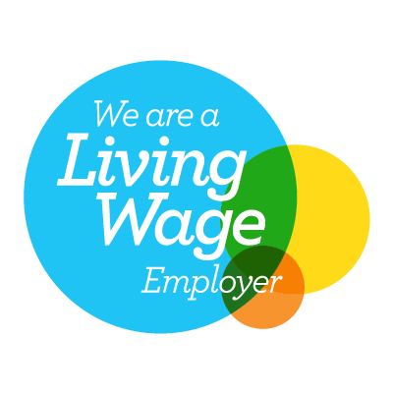

Person specification

Technical skills and minimum knowledge:
- Significant track record of successfully influencing politicians and/or key decision-makers to achieve policy change
- Strong communication skills (written and oral) with impact and for a range of audiences
- Experience of providing strategic input to support senior leadership
- Experience of line managing, including dealing with performance issues and supporting team development
- Self-sufficient use of IT, including proficiency in Word, Excel, PowerPoint, and experience in project management processes and software
Behaviours and competencies:
- Works collaboratively, managing challenges in a constructive manner
- Balances competing priorities and work to tight deadlines
- Demonstrates a dedication to the values of the Trussell Trust
- Demonstrates empathy for people from disadvantaged, marginalised or socially- excluded backgrounds
- Role models inclusive behaviour, values and leadership
Key Stakeholders
- Head of Policy, Research, and Campaigns, Senior Research Manager, Policy Campaigns Manager, and Director of Policy, Research, and Impact
- Policy and Public Affairs Manager (Scotland) and Network Leads for Wales and Northern Ireland
- Organising and Local Mobilisation team
- Public Engagement department, particularly in the Strategic Communications and Audience Insight and Engagement teams, and Changing Policy Business Partner
- UK government departments, including DWP, DEFRA, MHCLG, and HM Treasury
- UK parliamentarians
- Policy and public affairs partners in the sector

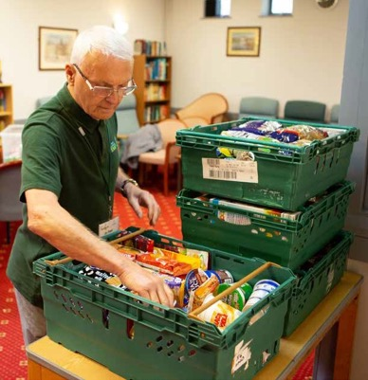
How to apply
The Trussell Trust is a charity that works to end the need for food banks. It is founded on and shaped by Christian principles.
Our values of dignity, justice, compassion and community, are central to all that we do and therefore supports our aim to be an organisation where the diversity of all employees is valued. We welcome people of all faiths and none and those that are committed to these values.
We recognise that we have under-represented groups within our workforce. As part of our commitment to diversity and equality of opportunity we are actively encouraging applications from under-represented groups such as returning parents or carers who are re-entering work after a career break, people who are LGBT+, from Black, Asian and Minority Ethnic backgrounds, with a disability, impairment, learning difference or long-term condition, with caring responsibilities, from different nations and regions and those with a lived experience of poverty as well as any other under-represented group in our workforce. We are committed to ensuring the safety and protection of our employees from all forms of harm.

If you feel you have the required passion, energy and enthusiasm to help us bring an end to poverty and hunger, then you’re on your way to becoming part of something that will make a real difference to people’s lives.

To apply for the role please go to our website to access our online application platform, Applied. This platform enables us to review your application anonymously to make our hiring decisions as diverse and impartial as possible.

You do not have to complete your application in one sitting, but you can save it and go back to it at any time before the closing date.

If you have questions about this position, please call
01722 580 209 or email recruitment@trusselltrust.org.

www.trusselltrust.org/jobs
The Trussell Trust is Reg. Charity in England & Wales (1110522) and Scotland (SC044246). Reg. Ltd. Co. in England & Wales (5434524)

