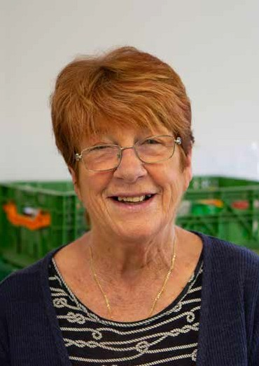

**www.trusselltrust.org**

Operations Assistant

APPLICANT INFORMATION PACK

[www.trusselltrust.org](http://www.trusselltrust.org/)

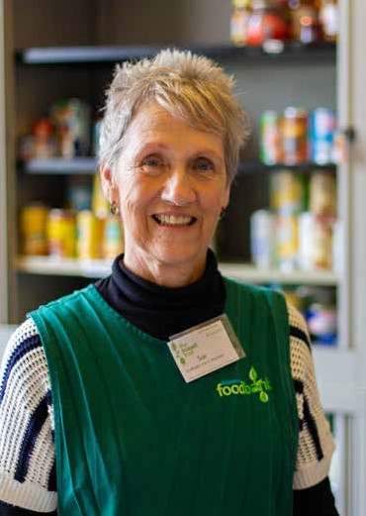



Although the Trussell Trust will always support food banks to help people in their community, we know that food is not the answer to poverty. Therefore, it would be wrong for us just to focus on providing the best possible emergency food to people in crisis today. Everyone should be able to afford the essentials in life, including food, and we want to see a future where no one needs to use a food bank.

While supporting emergency food provision will continue to be a core part of our work, we're first and foremost an anti-poverty charity. Alongside providing vital bespoke support to every food bank in our network, major additional services will be rolled out in food banks over the next year to help Change Communities, and we'll forge new relationships with agencies and organisations who can help people in crisis address their financial situation well before they reach the point of needing to access a food bank. But just as important will be our planned investment in research, advocacy, engagement and campaigning to Change Minds and Change Policy.

Our recruitment programme will be at the heart of this vital work, and we're incredibly excited that it will help us reach our vision quicker, providing thousands of people with the dignity of buying their own food. If you want to fight the injustice of hunger and poverty, and help people in crisis across the UK, we want to hear from you.

*The Trussell Trust is committed to a policy of Equal Employment Opportunity and is determined to ensure that no applicant or employee receives less favourable treatment on the grounds of gender, age, disability, religion, belief, sexual orientation, marital status, or race, or is disadvantaged by conditions or requirements which cannot be shown to be justifiable.*

**Emma Revie**

Chief Executive

Welcome from

Emma Revie, Chief Executive



Our values

What we Do

*14.2 million people in the UK population are in poverty.

The Social Metrics Commission, 2018

Our aim is to end hunger and poverty in the UK. We support a nationwide network of 1,200 food bank centres across the UK.

Together, we provide emergency food and support to people locked in poverty, and campaign for change to end the need for food banks in the UK for good.

In the UK, more than 14 million* people are living in poverty - including 4.5 million children. As a nation, we expect no one should be left hungry or destitute, and we owe it to each other to make sure the right support is in place when we need it most.

It’s simply not right that we live in a society where so many people are locked in poverty.

**Together, we can end hunger and poverty in the UK.**

The Trussell Trust is committed to community built on diversity, tolerance, cooperation, and mutual respect. We want to contribute to society and demonstrate social responsibility.

Our values are **Compassion**, **Justice**, **Community** and **Dignity**.

These are reflective of the values

we see embodied throughout the Trussell Trust network of food banks.

Whilst we recognise that charities, churches and organisations running food banks may hold additional or distinctive values, these are the values which we hold together as a network, and by which we hold one another accountable.

3



Our head office is based in Salisbury in Wiltshire, with satellite offices in London and Coventry.

We also have team members based across the UK supporting food banks at a local level.

Our support for the food banks in our network is delivered through five directorates, all of which report into our Chief Executive. These are:

     • Operations

     • Finance & Corporate Services

     • Policy, External Affairs & Research

     • Strategy & Impact

     • Public Engagement

Whatever your skills or experience, there could be a role for you at the Trussell Trust.

Our Benefits

How we Work

Our people are the most important thing the Trussell Trust has. Without our staff, we couldn’t achieve our goals and create change.

Our staff are passionate about their work and the difference they make to the lives of others. The benefits package we offer supports our staff professionally and personally.

Benefits include matched pension contributions of up to 8%, group income protection, payroll giving, flexible working, season ticket loans, and enhanced contractual leave.

To find out more about the full range of benefits we offer, visit [www.trusselltrust.org/employee-benefits.](http://www.trusselltrust.org/employee-benefits)



**Department:** Operations

**Responsible to:** Director of Operations

**Hours:** Full Time (37.5 hours per week)

**Salary:** £25,108.31 per annum plus benefits

**Based:** Salisbury or home based

**Employment type:** 12 months fixed term role with potential to extend

ROLE OUTLINE

This is a challenging and busy role supporting the Director of Operations and the wider Operations Directorate. The Operations Assistant is responsible for providing high level support to the Director of Operations and the Operations Leadership Team. The Operations Assistant supports the coordination and delivery of a range of projects, events and working groups across the Operations Directorate.

## Responsibilities

* Support the delivery and coordination of projects and working groups within the Operations Directorate.
* Support the Operations leadership team to manage Operations team engagement; planning meetings and working groups, taking minutes and assisting in the preparation of reports, communications, presentations and other documents
* Perform administrative duties for the Changing Communities Programme Board, scheduling meetings with colleagues and food bank network representatives, preparing agendas, recording minutes and producing reports for the Senior Leadership Group (SLG)
* Support the Operations Directorate through excellent stakeholder management, building positive relationships between teams across the Trussell Trust
* Act as a key contact point between the SLG and the Operations Directorate, ensuring expectations and objectives are met and all queries answered satisfactorily
* Organise and support the Director of Operations with regular operational events, both internally and for the food bank network, liaising with event management companies when appropriate
* Maintain the appointment schedule for the Director of Operations and when requested, the Operations Leadership team, by planning and scheduling meetings, video conferences, and travel arrangements for individuals
* Review incoming correspondence for the Director of Operations and take action as appropriate; drafting emails and documents, collecting and analysing information, initiating communication with key stakeholders
* Work with other stakeholders across The Trussell Trust to maintain central information, support resources, advice and guidance for the Operations Directorate
* Maintain client confidence and protect operations by keeping information confidential
* Actively contribute to a culture of respect, innovation, resourcefulness and best practice
* Promote collaborative and flexible working across the Operations Directorate the wider charity.

Any other reasonable duties as specified by the Director of Operations to support the work of the Trust.

The Role



Person specification

|  |  |
| --- | --- |
| Requirement | Measures of success |
| Experience of supporting the delivery of a range of projects, events and meetings  Outstanding administration skills  Comfortable working autonomously and across multiple tasks with a high degree of self-management and personal organisation  Experience of working in the third sector (desirable)  Experience of building relationships internally across an organisation with key stakeholders and representing the organisation at meetings | Length of service in similar role  Evidence of targets met  Demonstrates emotional intelligence required in the role |
| Excellent communication skills, both written and verbal  Excellent knowledge of MS Office applications, including Word, Excel, Outlook and PowerPoint  Highly numerate with the ability to present and analyse data  Excellent attention to detail  Able to manage a complex and busy role with competing deadlines using outstanding organisational skills  Ability to effectively represent the directorate internally and the organisation externally and promote core brand messages | Demonstrates a good understanding of the principles underlying GDPR, other applicable legislation and best practice  Shows good interpersonal skills, is amiable and approachable and written communication is succinct and convincing.  Has a clear idea of priorities and manages own and team’s time appropriately  Delivers key outputs and responds to requests in a timely fashion  Is able to represent the Trust and its values effectively |
| Is able to work through challenges in positive and effective ways.  Excellent decision-making ability  Clear understanding of the need to maintain confidentiality  Excellent social skills, able to operate with diplomacy, tact and empathy at all levels  Passionate about the work of the Trussell Trust and is sympathetic to its values and ethos | Demonstrate resilience, resourcefulness, flexibility and perseverance  Demonstrates personal integrity and commitment to the values of the Trussell Trust  Demonstrates empathy for people from disadvantaged, marginalised or socially-excluded backgrounds |
| Commitment to occasional need to work outside of normal working hours and travel throughout the UK | Is willing to be available for work related travel |

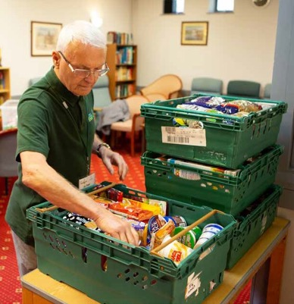

If you have questions about this position, please call   
01722 580 209 or email people@trusselltrust.org.

www.trusselltrust.org/jobs

The Trussell Trust is Reg. Charity in England & Wales (1110522) and Scotland (SC044246). Reg. Ltd. Co. in England & Wales (5434524)

If you feel you have the required passion, energy and enthusiasm to help us bring an end to poverty and hunger, then you’re on your way to becoming part of something that will make a real difference to people’s lives.

To apply for the role please go to www.trusselltrust.org/jobs and click on ‘Apply for this job’ by the role details. This will take you through to our online application platform, Applied. This platform enables us to review your application anonymously to make our hiring decisions as diverse and impartial as possible.

You do not have to complete your application in one sitting, but you can save it and go back to it at any time before the closing date.

How to apply